FOHOW HEALTHCARE PRIVATE LIMITED
Office no.213, South City One Arcade, Sector 41
Gurugram, Haryana - 122001 | GSTIN: 06AAGCF4657B1ZJ
📞 +91-8802856563 | 📧 dr.singh@fohow.com | www.fohow.com
PRODUCT CATALOGUE & PRICE LIST
WHY FOHOW?

- Founded in 1999, FOHOW has years of experience in perfecting not only products that set the gold standard in the industry, but also a duplicable home-based business model that is stable in a good economic climate or bad. Under the direction FOHOW’s solid and experienced management team, the company is positioned for a future of continued growth and success.
- Health & Wellness-related businesses have been one of the fastest growing segments in direct selling. Renowned economist, Paul Zane Pilzer identified wellness products and programs as the economy’s next trillion-dollar industry. As a large portion of the world population ages, they are looking for products that make them look and feel better, and younger generations are looking for ways to maintain their health and energy levels to meet the needs of their busy lives. FOHOW is poised to meet those needs.
- FOHOW’s quality products are formulated by a world-class scientific team based on cutting-edge, proven science and expertise in keeping cells healthy through optimal nutrition. The company also collaborates closely on research with the other notable institutions. Additionally, most products are manufactured and packaged in FOHOW’s own state-of –the art facility, allowing FOHOW to guarantee the quality and potency of every product.
- FOHOW Business Fits Your Life – It’s your business. You work where, when, and how you want. Generally, if you put in a little bit of work, you’ll earn a little bit of income. If you put in more work, your earnings will increase. And you’ll be free from the typical work week irritations – no alarm clock, no schedule, no rush hour, traffic, and no boss.
- Available for everyone – No previous experience necessary. Training is provided, allowing you to earn as you learn, regardless of age, sex, background, or education.
- Make a difference – Like working with people? Help improve the quality of people’s lives.
- Worldwide Credibility – FOHOW is present in 100 + countires, and has attracted people of all ages, genders, and education levels from across the globe. World-class athletes, best-selling authors, respected scientific institutions, leading health and wellness experts, and experienced business professionals across the globe have all recognized FOHOW’s commitment to excellence.
- FOHOW is behind you every step of the way. You will receive expert training and have access to a wealth of tools to make your life easier: a full Associate-only Web site where you get the latest news, training, free downloads, and business management services; frequent Web conferences; unforgettable events; eye-catching sales aids, professional multimedia productions; exciting publications; and much more. Our enthusiastic and experienced customer service team is available to help in several languages.
- If you’ve always wanted to travel the world, FOHOW is your ticket to a successful international business. FOHOW responsibly expands by choosing promising markets around the world in which to open for business. With our seamless compensation plan, you can build your organization in multiple countries without having to worry about different compensation plans or currency conversations. FOHOW takes care of everything while you work in exotic locations, discover exciting cultures, and make a world of new friends.

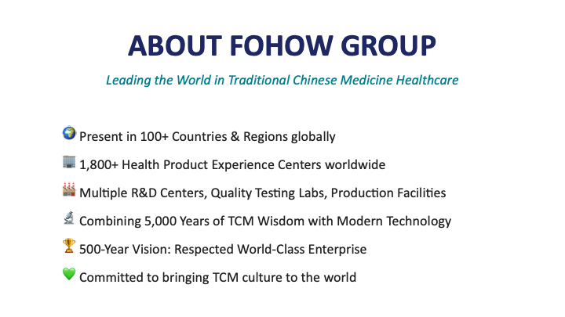

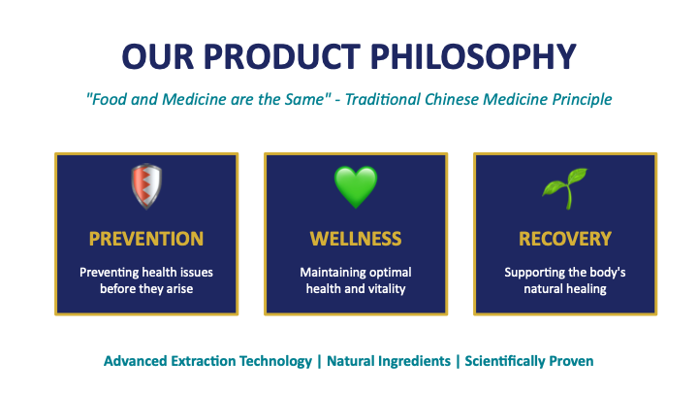

HEALTH SUPPLEMENTS

PRODUCT NAME | CODE | QTY | MRP (₹)
FOHOW Linchzhi Spore Capsules | FH-LIN-100 | 100 caps | In process
FOHOW Haicao Gai Calcium Capsules | FH-CAL-100 | 100 caps | In process
FOHOW Gaoqian Nutritional Tablets | FH-GAO-180 | 180 tabs | In process
FOHOW Boss Tea (Liuwei Tea) | FH-TEA-40 | 40 bags | In process

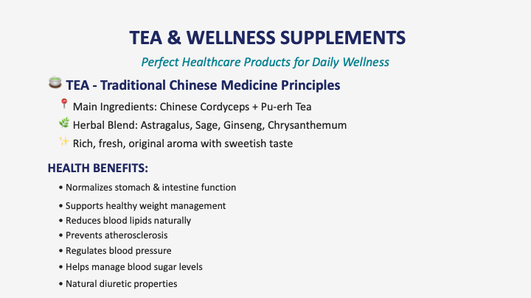

WELLNESS DEVICES & THERAPEUTIC EQUIPMENT

PRODUCT NAME | CODE | QTY | MRP (₹)
YANG-SHENG Meridian Massager | FH-YSM-01 | 1 unit | In process
Revitalizing Energetic Massager | FH-REM-01 | 1 unit | In process
Blood Circulation Machine (BCM) | FH-BCM-01 | 1 unit | In process
HYDROGEN WATER ACTIVATOR | FH-H2W-01 | 1 unit | In process
Graphene Waist Massager | FH-GIW-01 | 1 unit | In process
Graphene Shoulder Massager | FH-GIS-01 | 1 unit | In process
Thermal Waist Belt | FH-FTW-01 | 1 belt | In process
Thermal Neck Belt | FH-FTN-01 | 1 belt | In process

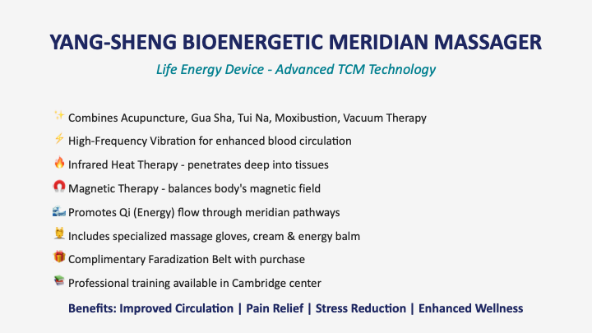

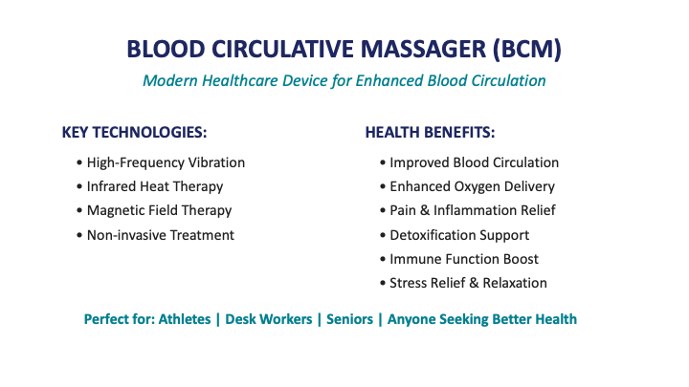

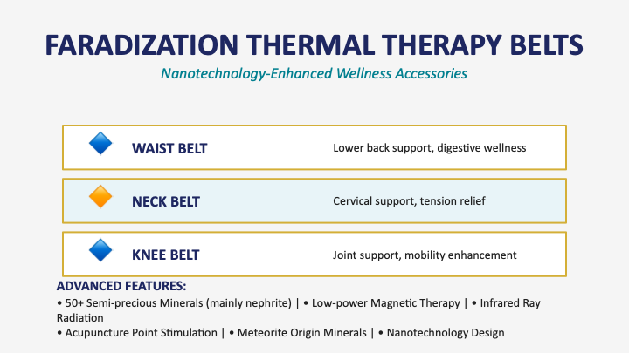

PERSONAL CARE & HYGIENE PRODUCTS

PRODUCT NAME | CODE | QTY | MRP (₹)
FOHOW Sanitary Pad | FH-SAN-R | 10 pads | In process
FOHOW Everyday Pad | FH-SAN-D | 20 pads | In process
FOHOW Herbal Massage Oil | FH-OIL-200 | 200ml | In process
FOHOW Energy Balm | FH-BAL-30 | 30g | In process
SlimPower Capsules | FH-SLM-60 | 60 caps | In process
Active ProBio | FH-PRO-30 | 30 sachets | In process
Movement Plus | FH-MOV-60 | 60 tabs | In process
FOHOW Gloves (3.0) | FH-GLV-3.0 | 1 pair | In process

FOHOW Everyday And Everynight Sanitary Napkins

FOHOW series of sanitary napkins are divided into daytime-use and night-use napkins types, and sanitary pads. They are high-tech and patented menstrual health and hygiene supplies for females which combine physical effects of nano-silver ions, far infrared and negative ion together. All these products are green natural, healthy and safe with unique efficacies of being antibacterial, dispelling peculiar smell, promoting the micro-circulation and maintaining the micro-ecological balance of body. In the special days, FOHOW series of sanitary napkins will give the most attentive care to all the ladies!

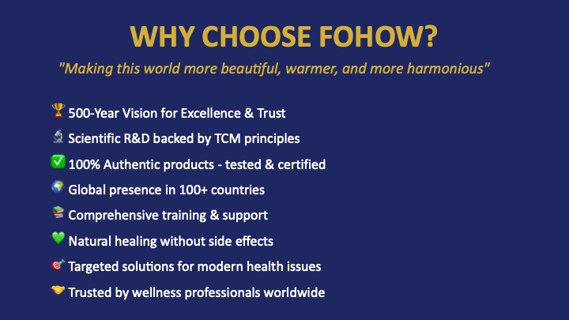

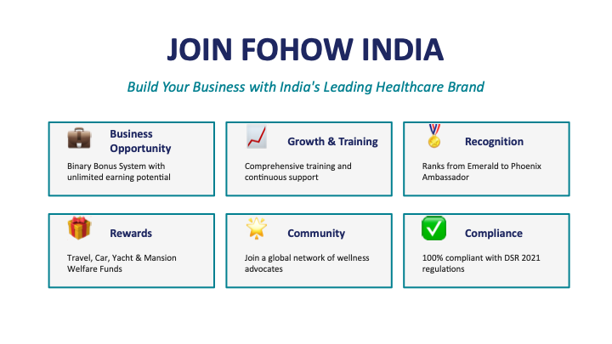

CONTACT US
For Orders & Inquiries:
C/O Ramesh Singh, FOHOWHealthcare Pvt Ltd
📞 +91-8802856563 | 📧 dr.singh@fohow.com | www.fohow.com

